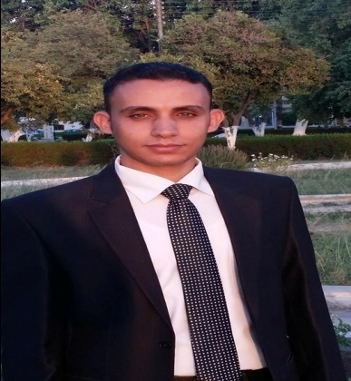
LANGUAGES :
English : high degree " written and spoken "
COMPUTER SKILLS :
Net : General knowledge .
Other :,Word .Excel ,Autocad, Sap2000,Arc gis

1- work as a team member toward common goals.
2- able to work well with all levels of management & people
- Name : Romany Hamdy Welson
- Address : Assuit-dayrout
- Nationality : Egyptian
- Birth Place : Assuit
- Date Of Birth : 10 / 8 / 1986
- Marital Status : Single
- Military Service : Finished
- Mobile : 01281049822
- E-mail : Romany_hamdy@yahoo.com

